Prepared By: Shoaib Munir
Day 2: Planning the Technical Foundation
System Architecture Document Date: 16-01-2025
Overview
The system architecture of the furniture e-commerce platform is designed to ensure scalability, reliability, and seamless user experience. The architecture integrates the front-end, back-end, database, and third-party services effectively.
Diagram
A detailed diagram is presented below, showing how the frontend interacts with Sanity CMS and third-party APIs. It includes components like:
- Frontend: User interface built using modern frameworks for seamless interactions.
- Sanity CMS: Content management system to handle dynamic product data.
- Third-party APIs: Services like payment gateways and shipping providers.

Diagram:
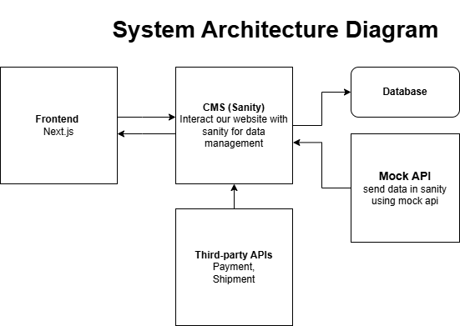

Components
- Frontend:
- Framework: Next.js
- Features: Responsive design, user-friendly interface, and dynamic content rendering.

- Backend:
- Framework: Node.js
- Features: API management, authentication, and business logic processing.

- Sanity CMS:
- Purpose: Storing user details, product catalog, orders, inventory, and analytics data.

- Third-Party APIs:
- Payment Gateway: Cash on Delivery
- Shipping Integration: Ship Engine
- Notification System: Gmail for email.

- Hosting and Deployment:
- Cloud Provider: Vercel for deployment.

Interaction Between Components
- Frontend communicates with the backend via RESTful APIs.
- Backend interacts with the database for CRUD operations.
- Backend integrates with third-party services for payments, shipping, and notifications.

